Case Study: 58-Library Borrowing and Fine Reconciliation

1. Problem Statement
Develop a Python program to manage library book borrowing and fine calculation. The program should accept the student's name, book name, number of days the book was borrowed, and the allowed borrowing period. It should calculate the overdue days and fine amount based on a fixed fine rate per day. Finally, it should display the borrowing details, overdue status, and total fine payable.

2. Objectives
- To record student and book details.
- To accept the number of borrowed days and the permitted borrowing period.
- To calculate overdue days using conditional statements.
- To calculate the fine amount for overdue books.
- To identify whether a book is returned on time or overdue.
- To display the final fine amount clearly.

3. Assumptions
- The student enters valid details.
- The borrowing period and number of borrowed days must be non-negative integers.
- The allowed borrowing period is 14 days.
- The fine rate is ₹5 per overdue day.
- No fine is charged if the book is returned within the allowed period. The fine is Fine =

4. Algorithm
- Start the program.
- Read the student's name and book name.
- Read the number of days the book was borrowed.
- Set the allowed borrowing period to 14 days.
- Set the fine rate to ₹5 per overdue day.
- Compare the borrowed days with the allowed period.
- If borrowed days are less than or equal to 14, set overdue days and fine to zero.
- Otherwise, calculate overdue days and fine amount.
- Display the student details, book details, overdue days, and fine amount.
- Stop the program.

5. Flowchart

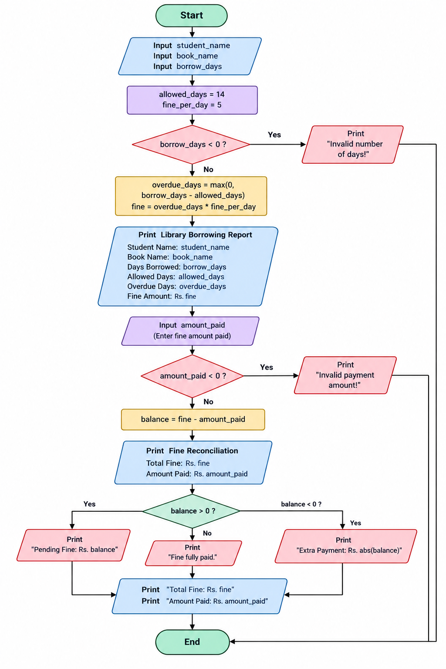

6. Pseudocode
BEGIN

INPUT student_name
INPUT book_name
INPUT borrowed_days

allowed_days = 14
fine_rate = 5

IF borrowed_days <= allowed_days THEN
overdue_days = 0
fine = 0
status = "Returned on time"
ELSE
overdue_days = borrowed_days - allowed_days
fine = overdue_days * fine_rate
status = "Overdue"
END IF

DISPLAY student_name
DISPLAY book_name
DISPLAY status
DISPLAY overdue_days
DISPLAY fine

END

7. Test Cases
Test case | Borrowed days | Overdue days | Expected fine | Status
1 | 7 | 0 | ₹0 | On time
2 | 14 | 0 | ₹0 | On time
3 | 17 | 3 | ₹15 | Overdue
4 | 20 | 6 | ₹30 | Overdue
5 | 30 | 16 | ₹80 | Overdue

8. Output

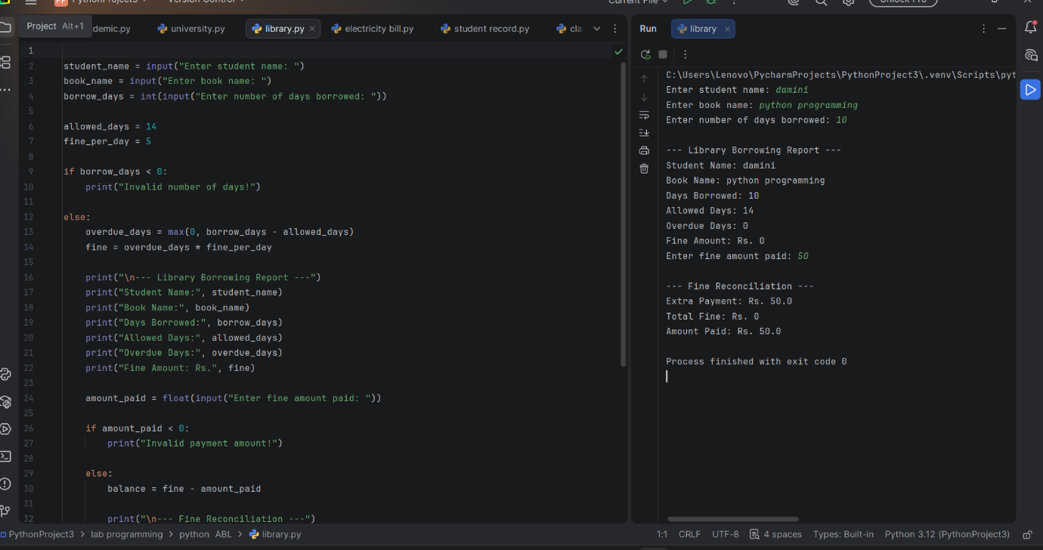

9. Conclusion
The Library Borrowing and Fine Reconciliation program successfully calculates overdue days and fines based on the library's borrowing rules. It uses variables, arithmetic operations, and conditional statements to determine the fine payable. This program helps simplify library fine calculations, reduces manual errors, and improves the efficiency of library management.

